**Installing Visual Studio Code on Windows**

Follow the below steps to install Visual Studio Code on Windows:

Step 1: Visit the [official website](https://code.visualstudio.com/docs/?dv=win) of the Visual Studio Code using any web browser like Google Chrome, Microsoft Edge, etc.

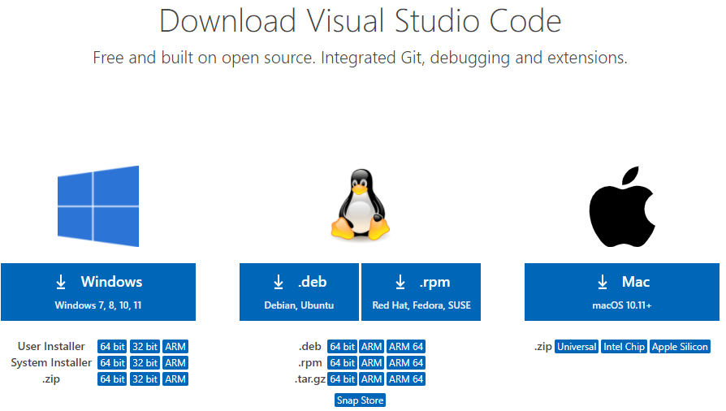

Step 2: Press the “Download for Windows” button on the website to start the download of the Visual Studio Code Application.



Step 3: When the download finishes, then the Visual Studio Code icon appears in the downloads folder.

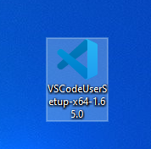

Step 4: Click on the installer icon to start the installation process of the Visual Studio Code.

Step 5: After the Installer opens, it will ask you for accepting the terms and conditions of the Visual Studio Code. Click on I accept the agreement and then click the Next button.

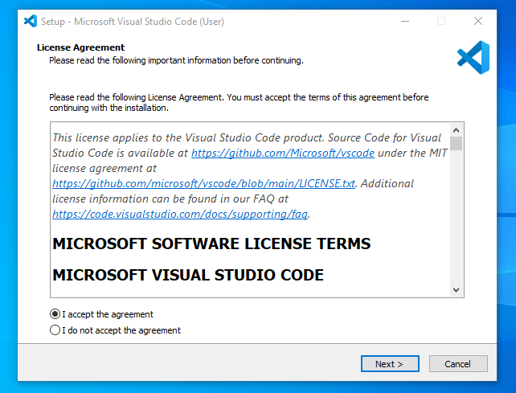

Step 6: Choose the location data for running the Visual Studio Code. It will then ask you for browsing the location. Then click on Next button.

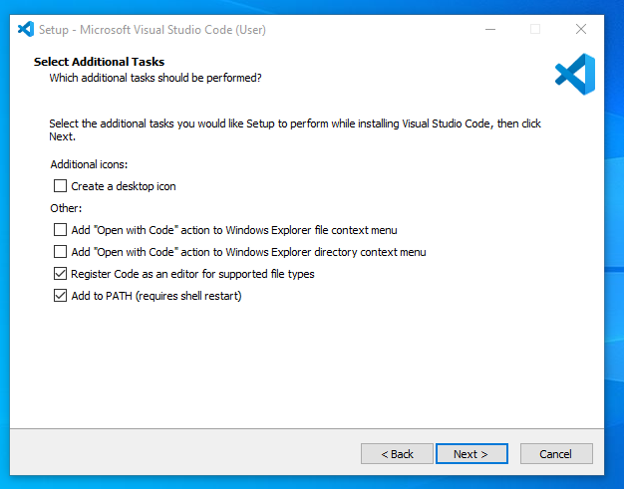

Step 7: Then it will ask for beginning the installing setup. Click on the Install button.

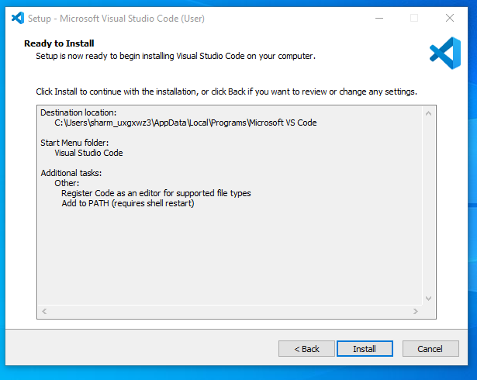

Step 8: After clicking on Install, it will take about 1 minute to install the Visual Studio Code on your device.

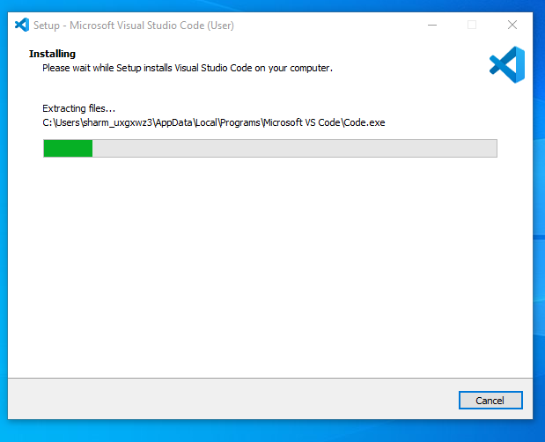

Step 9: After the Installation setup for Visual Studio Code is finished, it will show a window like this below. Tick the “Launch Visual Studio Code” checkbox and then click Next.

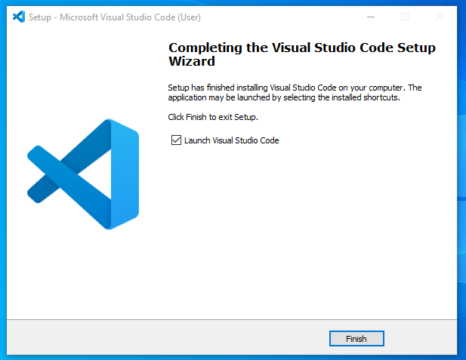

Step 10: After the previous step, the Visual Studio Code window opens successfully. Now you can create a new file in the Visual Studio Code window and choose a language of yours to begin your programming journey!

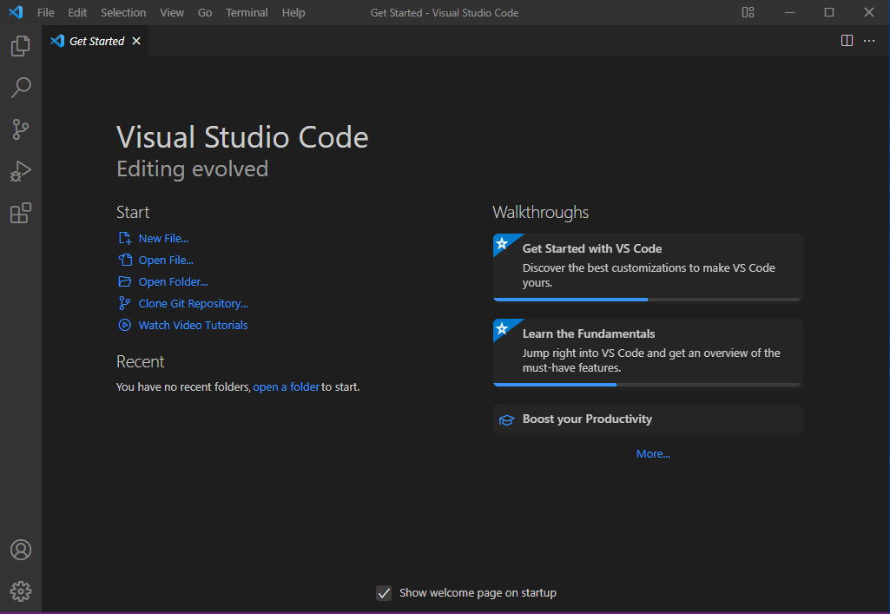

So this is how we successfully installed Visual Studio Code on our Windows system.